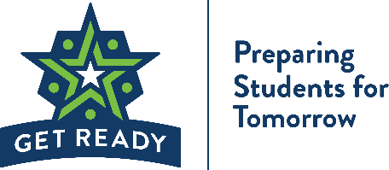

Guidance for Distance Learning with the Career Pathways Curriculum
The Get Ready program would like to congratulate you on your continued efforts to educate and provide learning experiences for Minnesota students! We have created a page on the Get Ready website that separates the Student Workbook into unique lessons and provides you with a set of PowerPoints for each lesson. These PowerPoints are instructional and may be used in the classroom or on online. We know that each of you have developed your unique way to connect with students. Please consider the PowerPoints as a base framework to work with in creating your lesson power point. The curriculum lessons were created for students to learn in concert with their peers- with and from one another. When they are translated into distance learning lessons, it may not be possible for students to connect with one another so we have tried to consolidate useful tips on ways to think about each section of the curriculum and how it best translates to individual learning.
- Start each session with a scripted video chat or power point presentation with students. Items to include:
- Objectives: Display the objectives of each lesson so that students will clearly know of the following objectives of each lesson:
          - From this lesson you will understand
          - Essential questions that will be answered
          - From this lesson you will know
          - From this lesson you will be able to
          - What product the student will have produced by the end of the lesson (Performance Task)
- Opening: Translate the opening discussion into pre-work. At the end of most opening activities, there are questions prompts for the class. Flip them into thought prompters that students will keep in mind as they delve into the new subjects.
- Introduction to New Materials: This will be the easiest piece of the distance learning session as this part of the lesson is often written as Instructor led.
- Guided Practice: Give students directions with a follow-through that they will answer to show that they understand the information. Students should have a call-back to the process/information that they will perform to show that they understand it and are able to move to the independent portion.
- Independent Practice: Set up a scenario that aligns with the students’ experience or create space so that students can make their own connection.
- Closing: The concluding activity allows the student to come to their own conclusions about the work they have done. Reflection is important for students to internalize that learning.

- Things to consider when creating your plan around lesson delivery:
- How this lesson flows and connects with the other lessons in the module.
- Definitions of key words and ideas.
- Suggestions about how students can have conversations about subject matter with family, friends and classmates.
- Make sure to include what is expected of students to complete and how they should send you the work when they are finished.
- If you are going to grade the work within the lessons, you can use the provided grading rubrics provided by Get Ready.
- Some lessons just won’t translate to a distance learning session. Consider the content and devise another way to approach the more sensitive topics.

- Reach out to your Get Ready contact for help. While we have cleared a few hurdles in providing for Minnesota students, we know that there will be more in the coming weeks. Your partnership and feedback remains an important part of how we can continue to improve. Please reach out to us, if you have any questions, concerns, or need additional support.

___________________________________________________________________________________________
1450 Energy Park Drive, Suite 350, St. Paul, MN 55108
TEL (651) 642·0567 | FAX (651) 642·0675| EMAIL Sharon.mule@state.mn.us | WEB www.getready.ohe.state.mn.us

